**EXPERIMENT NO. 4**

**Aim:** Perform Simple queries based on Numeric, Character and Date SQL functions.

**Theory:**

Explain different Numeric, Character and Date SQL functions.

**Lab Manual:**

**a) Numeric Functions**: It accept numeric input and return numeric values as output. **i. Abs (n):** This function returns the absolute value of the given number. **SQL> select ABS (-15) from dual;**

**Absolute**

**----------**

**15**

**ii. Cos:** COS returns the cosine of an angle expressed in radians.

**SQL> select cos (0) from dual;**

**COS (0)**

**----------**

**1**

**iii. Sin:** SIN returns the sine of an angle expressed in radians.

**SQL> select sin (30 * 3.14/180) “Sine” from dual;**

**Sine**

**-----------**

**.5**

**iv. Tan:** TAN returns the tangent of an angle expressed in radians.

**SQL> select tan (135 * 3.14/180) “Tan” from dual;**

**Tan**

**-----------**

**-1**

**v. Round:** ROUND returns *a value* rounded to *integer* specified to be placed to the right of the decimal point.

**SQL> select round (15.193, 1) “Round” from dual;**

**Round**

**-----------**

**15.2**

**vi. Truncate:** The TRUNC function returns *a number value (x)* truncated by a number (y) to its decimal places.

**SQL> select Trunc(15.79, 1) “Truncate” from dual;**

**Truncate**

**-----------**

**15.7**

**vii. Power:** POWER returns *n2* raised to the *n1* power.

**SQL> select Power (3, 2) “Power” from dual;**

**Power**

**-----------**

**9**

**b) Character Functions:** It accept character input and return character values as output. **a) LOWER:** Converts mixed case or uppercase character string to lowercase. **SQL> select lower (city) from emp;**

**LOWER (CITY)**

**-----------------------------------**

**mumbai**

**pune**

**nagpur**

**b) UPPER:** Converts mixed case or lowercase character string to uppercase. **SQL> select upper (city) from emp;**

**UPPER (CITY)**

**-----------------------------------**

**MUMBAI**

**PUNE**

**NAGPUR**

**c) INITCAP:** Converts first letter of each word to uppercase and remaining letters to lowercase.

**SQL> select initcap (f_name) from emp;**

**INITCAP (F_NAME)**

**-----------------------------------**

**Anil**

**Sunil**

**Smita**

**d) CONCATE:** Use to concatenate value of one or more columns and display it or concatenate string with the columns and display it.

**SQL> select concat(ID, f_name) from emp;**

**CONCAT (ID, F_NAME)**

**-----------------------------------**

**E01 Anil**

**E02 Sunil**

**E03 Smita**

**e) LTRIM:** Use to trim/cut characters contained in the set from the left side.

**SQL> select Ltrim(‘Nagpur’, ‘Nag’) as Leftm from emp where f_name= ‘Anil’; LEF**

**------**

**pur**

**f) RTRIM:** Use to trim/cut characters contained in the set from the rightside. **SQL> select Rtrim (‘Mumbai’, ‘bai’) from emp where f_name= ‘Sunil’;**

**RTR**

**------**

**Mum**

**g) SUBSTRING:** It returns a part of string, beginning at a given character position and ends where the substring_length specified ends. If the staring character of substring not specified then it takes first character as default.

**SQL> Select substr (‘Mumbai’, 1, 3) “Substring” from dual;**

**Substring**

**-----------**

**Mum**

**h) LENGTH:** It takes the character as input and returns the length of the string as an output. Output is measured in bits by default, for measuring in bytes we need to write Lengthb. **SQL> select Length (‘Nagpur’) as Len from emp where f_name= ‘Smita’;**

**LEN**

**------**

**6**

**i) REPLACE:** It takes the string as input in which character needs to be replaced. Also takes old and new characters that are to be replaced with each other. So it searches the old character occurrence in the string and replaces it with the new character.

**SQL> Select replace (‘Jack and Jue’,’J’, ‘BL’) “Changed_String” from dual; Changed_String**

**-----------**

**Black and Blue**

**c) Date Time Functions:** Oracle stores dates in default date format as DD-MON-YY. It basically comprises of: century, year, month, day, hours, minutes, and seconds.

**a) TO_CHAR:** Converts a date or number to a string

**SQL> Select to_char (DOJ, ‘Month, DD, Year’) as “Date_in_string” from Month; Date_in_string**

**-------------------**

**JAN, 01, 2013**

**JAN, 01, 2013**

**b) ADD MONTH (D, N):** It takes as input a date and adds one month to that date and displays the result.

**SQL> Select add_months (DOL, 1) as “Added month” from Month;**

**Added month**

**-------------------**

**01-MAR-13**

**01-MAY-13**

**c) LAST DAY (D):** It takes as input a date and for that date returns the last date of its month. **SQL> Select Last_day (DOL, 1) as “Last day of month” from Month;**

**Last day of month**

**-------------------**

**28-FEB-13**

**30-APRIL-13**

**d) MONTHS_BETWEEN (D1, D2):** It takes as input 2 dates and returns number of months between these two dates.

**SQL> Select months_between (DOL, DOJ) as “Bet_month” from Month;**

**Bet_month**

**--------------**

**1**

**3**

**e) MONTH (DATE):** It takes as input a date and returns the month number of that date as a result. **SQL> Select month (DOL) as “Month no” from Month;**

**Month no**

**--------------**

**2**

**4**

**f) MONTHNAME (DATE)** It takes as input a date and returns the month name of that date as a result.

**SQL> Select monthname (DOL) as “Month name” from Month;**

**Month name**

**--------------**

**February**

**April**

**g) DAYNAME (DATE):** It takes as input a date and returns the weekday name of that date as a result.

**SQL> Select dayname (DOL) as “Week day” from Month;**

**Week day**

**--------------**

**Friday**

**Monday**

**h) DAYOFMONTH (DATE)**: It takes as input a date and returns which day it is of that month, the result is always between 1 t0 31.

**SQL> Select dayofmonth (DOL) as “Day no” from Month;**

**Day no**

**--------------**

**1**

**1**

**i) DAYOFWEEK (DATE):** It takes as input a date and returns which day it is of the week, the result is always between 1 t0 7.

**SQL> Select dayofweek (DOL) as “Week Day no” from Month;**

**Week Day no**

**--------------**

**6**

**2**

**j) DAYOFYEAR (DATE):** It takes as input a date and returns which day it is of that year, the result is always between 1 t0 365.

**SQL> Select dayofyear (’27-02-03’) as “Year Day no” from dual;**

**Year Day no**

**--------------**

**34**

**k) NOW ():** It is a date function used to display from dual the system current date and time together.

**SQL> Select Now ( );**

**Now ()**

**--------------**

**‘2014-06-17 23:50:26’**

**l) CURDATE ():** It is a date function used to display from dual the system current date. **SQL> Select Curdate ( );**

**Curdate ()**

**--------------**

**‘2014-06-17’**

**m) CURTIME ():** It is a date function used to display from dual the system current time. **SQL> Select Curtime ( );**

**Curtime ()**

**--------------**

**n) NEXTDAY():** It is a date function used to display the next day.

**SELECT NEXT_DAY('02-FEB-2001','TUESDAY') "NEXT DAY"**

**FROM DUAL;**

**NEXT DAY**

**-----------**

**06-FEB-2001**

**‘23:50:26’**

**Implementation:**

5. Apply SQL function for given exercise

**Exercise:**

1. Create table Flight(F_id, DoT, DoI, Time, Pass_name, Source, Destination, Fare) where DOT is Date of travel and DOI is the date of issue



1. Insert 5 values

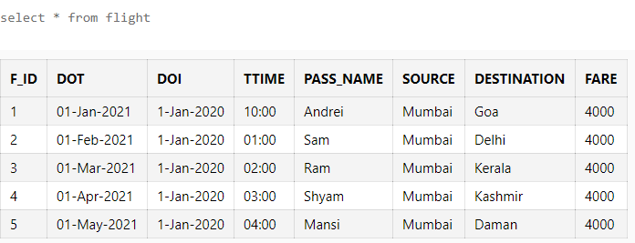

1. Display today’s date and time in the prompt.

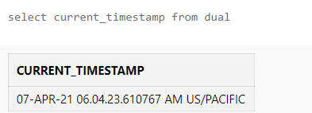

1. Display the absolute value of -184.

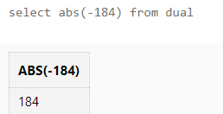

1. Select a value from the dual and for that value find its cube.

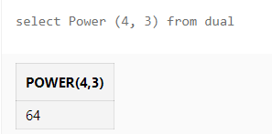

1. Display the date (doI) 2 months after date of Issue of Ticket.

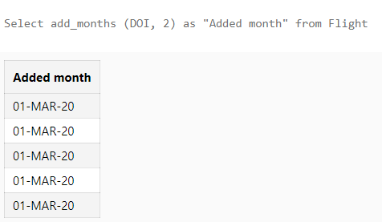

1. Display the last day of month of date of Travel.

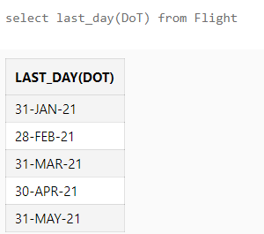

1. Display the month between date of travel and date of Issue.

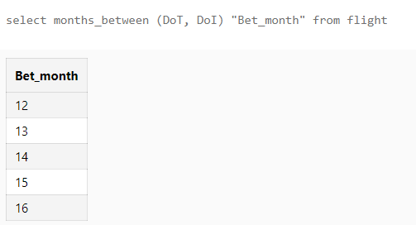

1. Display the next occurrence of Monday from the day of Travel.

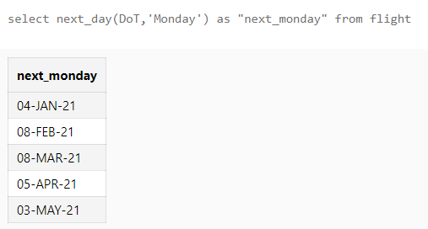

1. Display the First letter of Pass_name into capitals.

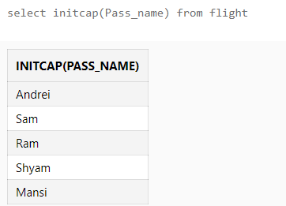

1. Display the Pass_name into upper case.

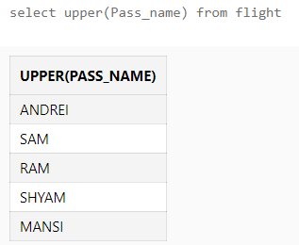

1. Display the Destination & source name into Lower case.

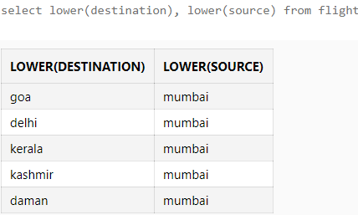

1. Display the first 3 characters of the Destination place name.

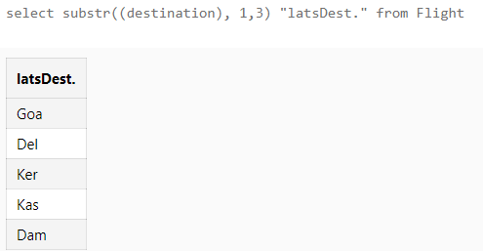

1. Display the last 3 characters of the Destination place name.

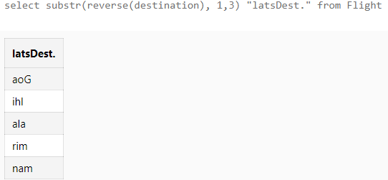

1. Display the pass name that begins with ‘m’ and replace with ‘B’.

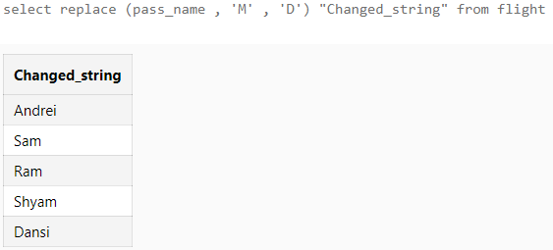

1. Display only 3 characters from the 3rd character with names of Source.

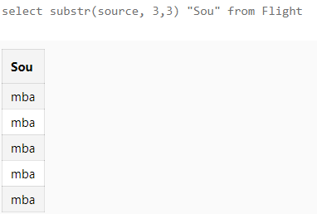

1. Display the rounded value of fare up to 2 characters.

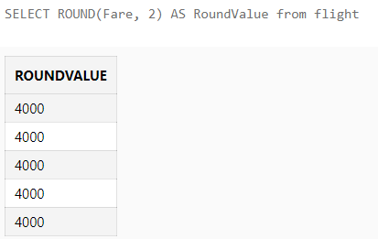

1. Display 20th September 2008 in the date format.

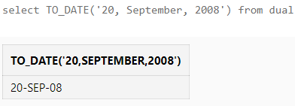

1. Display the day truncated up to the year for the DOT in the Flight table.

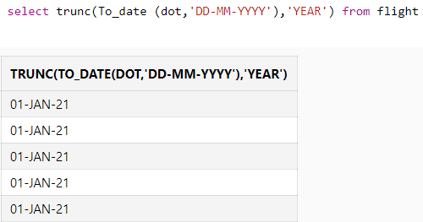

1. Take DOT as input and display the output like “my travel Date is ”.

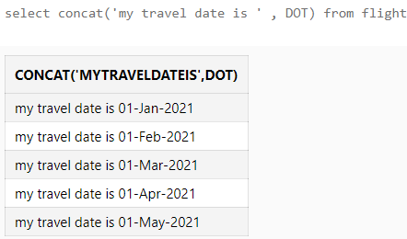

**Conclusion:**

With the help of this experiment, we learned character, numeric and date & time functions. These built-in functions help us in retrieving data easily as per the requirement.